H2 - Does odor precede sampling-bout onset?
Directional, non-circular test of odor -> behavior at bout onset (Selective Sampling-Bout analysis, reactions_2)
Result: H2 is NOT supported. In the pre-onset window [-0.75, -0.25] s the baseline-subtracted ethanol (median 0.0197 a.u.) is NOT above the trial baseline (median 0.0236 a.u.); if anything it is slightly lower (delta = -0.0038 a.u.). Wilcoxon pre > baseline p = 0.6493; pre > matched-null p = 0.9397; and the onset-aligned slope over [-1, 0] s is not positive (median 1.24e-04 a.u./s; slope > 0 p = 0.4324). Odor does not rise ahead of deliberate sampling bouts.

1. Goal and hypotheses
A sampling bout is a rare, deliberate event defined by a locomotor pause plus a head cast (a translation-invariant head-body bearing angular speed, omega). H2 asks a directional question: does odor RISE before the animal initiates such a bout? A leading odor rise would be evidence that the odor drives the decision to sample, rather than the sample merely coinciding with odor.
Non-circular by construction. This test replaces the v1 claim that 'COM slows during sweeps'. That claim was CIRCULAR here: a locomotor pause (low COM speed) is part of the very definition of a bout, so 'slowing' is definitional, not a finding. H2 instead measures the odor signal independently of the pause and the cast that define the bout, and asks only about its time course before onset.
H2 (directional): pre-onset ethanol in [-0.75, -0.25] s exceeds BOTH (a) the trial baseline (trial median baseline-subtracted ethanol) AND (b) a matched random-time null, with a positive onset-aligned slope over [-1, 0] s; and this precedence is specific to deliberate bouts (surviving incidental-event and spatial controls). Accept only if all hold.
H0: pre-onset ethanol equals the trial baseline / matched null, with no positive onset slope, and any pre-onset structure is not specific to bouts.

2. Methods
Data were read through the project accessor only and processed with the shared library code/reactions2_common.py (which reuses reactions/code/reactions_common.py; no science re-implemented). All computation used the pinned interpreter (vras/Scripts/python.exe), headless matplotlib (Agg), fixed seed 1234.
Replication unit is the TRIAL (one statistic per trial), pooling Loc1-6 (n = 105 trials); anotherLoc (n = 9) is held separate. Only trials with at least one bout contribute to the bout-conditioned tests.
Bout detector (final parameters, D6 rarity gate PASSES; not loosened, d6_tightened = False): v_pause = 5.89 px/s (25th pct of pooled COM speed), tau_pause = 0.30 s, dphi_min = 40 deg, omega_min = 156.6 deg/s (90th pct of pooled omega), t_merge = 0.50 s. Achieved pooled median bout rate = 0.00733 /s (~232x rarer than the v1 baseline of 1.7 /s).
Odor signal and precedence measures. Ethanol is baseline-subtracted on the raw scale (raw minus a rolling 10th-percentile, 20 s window), on the head clock. Signals are onset-aligned (bout onset at t = 0) on a +/-1.0 s, 50 ms grid. Precedence is scored three ways, per trial: (i) pre-onset level = mean baseline-subtracted ethanol in the pre-onset window [-0.75, -0.25] s; (ii) the trial baseline = the trial median baseline-subtracted ethanol (the comparator for the pre-onset level); and (iii) the onset-aligned slope = the linear slope of the mean ethanol over [-1, 0] s. A matched random-time null draws same-count events at random times within the same trial.
Controls (specificity). (1) Incidental-event control: the same pre-onset > baseline test is run on incidental high-omega-while-moving events (the contrast class). H2 is specific only if incidental events do NOT show a pre-onset odor rise. (2) Spatial split: pre-onset odor for bouts starting inside odor-reached space vs outside; a genuine odor-triggered process should show a higher pre-onset level for in-odor bouts.
Inference is trial-level Wilcoxon (never per-event point-bootstrap); permutation null uses 2000 draws, trial-bootstrap 2000 draws, seed 1234, odor cutoff 0.001. Direction and magnitude are reported before p-values; no family-wise correction (per-test).

3. Results
Magnitude and direction first (the p-value is secondary). Averaged over contributing trials, the pre-onset ethanol is 0.0197 a.u. - which is not above but slightly below the trial baseline of 0.0236 a.u. (delta = -0.0038 a.u.). The direction is opposite to H2: there is no pre-onset rise.
(a) Pre-onset vs trial baseline: the trial-level Wilcoxon test of pre-onset > baseline gives p = 0.6493 (one-sided; stat = 200.0, n = 29 contributing trials) - no evidence that pre-onset odor exceeds the trial baseline.
(b) Pre-onset vs matched null: pre-onset > null p = 0.9397 (stat = 146.0, n = 29) - again null, with the direction against H2.
(c) Onset-aligned slope: the median onset-aligned slope over [-1, 0] s is 1.24e-04 a.u./s, and the trial-level test of slope > 0 gives p = 0.4324 (stat = 226.0, n = 29). Odor is not ramping up into bout onset.
Controls strengthen the null.
(d) Incidental-event control. The same pre-onset > baseline test on incidental high-omega events is strongly positive: p = 1.67e-08 (stat = 4510.0, n = 105 trials). So a pre-onset odor rise DOES exist - but for incidental, unstructured motion, not for deliberate sampling bouts. If anything, odor precedes incidental motion; deliberate bouts are not the odor-triggered class. This is the opposite of what H2 requires, and it rules out a mere sensitivity/power explanation for the null on bouts (the test can detect a pre-onset rise when one is present).
(e) Spatial control. Splitting bouts by starting location, the pre-onset odor is NOT higher for in-odor bouts (median 0.0159 a.u., n = 20 bouts) than for out-of-odor bouts (median 0.0192 a.u., n = 35 bouts) - in fact it is slightly lower. A genuine odor-triggered process would predict the reverse.
All three primary conditions fail and both controls point against precedence, so H2 is rejected (accept_H2 = False). Because odor is measured independently of the pause and cast that define a bout, this is a non-circular test: the null is a real negative on odor -> behavior precedence, not an artifact of the bout definition.

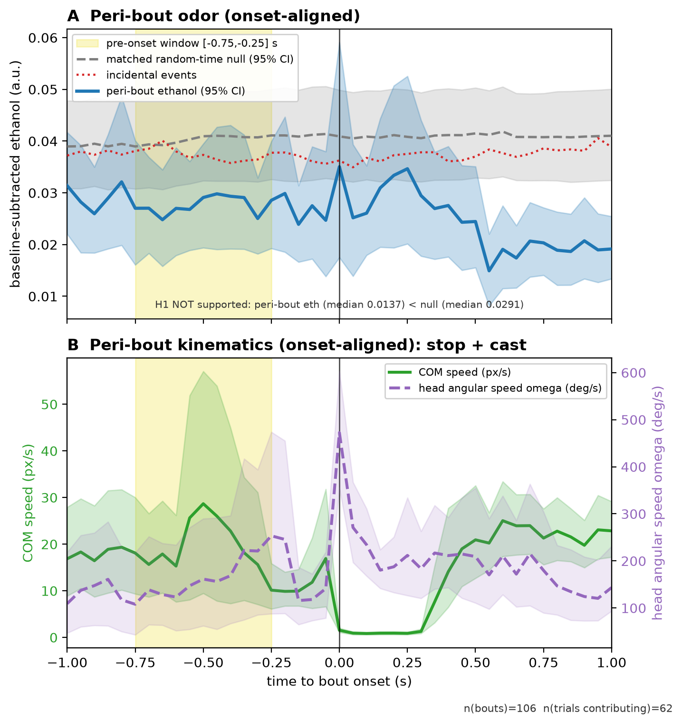
Figure F2. Onset-aligned peri-bout signals (pooled Loc1-6; n(bouts) = 106, n(trials contributing) = 62; vertical line at bout onset, t = 0). (A) Mean onset-aligned baseline-subtracted ethanol (a.u.) with 95% trial-bootstrap CI, overlaid on the matched random-time null and the incidental-event curve; the shaded band marks the pre-onset window [-0.75, -0.25] s tested by H2. The ethanol trace shows no rise approaching onset - it sits at or below the trial baseline through the pre-onset window (pre-onset median 0.0197 a.u. vs baseline 0.0236 a.u.; slope over [-1, 0] s ~ 1.24e-04 a.u./s). (B) Mean onset-aligned COM speed (px/s) and head angular speed omega (deg/s), showing the locomotor stop at onset accompanied by the head cast that define the bout - the behavioral signature is clear even though the odor does not lead it. Shared with the H1 report.

3.1 Key numbers
Quantity | Value
Median pre-onset ethanol, [-0.75,-0.25] s (a.u.) | 0.0197
Median trial baseline ethanol (a.u.) | 0.0236
Delta (pre-onset - baseline) (a.u.) | -0.0038
Wilcoxon pre > baseline, p (one-sided) | 0.6493
Wilcoxon pre > matched null, p (one-sided) | 0.9397
Median onset-aligned slope, [-1,0] s (a.u./s) | 1.24e-04
Wilcoxon slope > 0, p (one-sided) | 0.4324
Control - incidental pre > baseline, p (one-sided) | 1.67e-08
Control - spatial pre-onset, in-odor (a.u.) | 0.0159
Control - spatial pre-onset, out-of-odor (a.u.) | 0.0192
Contributing trials (primary tests) | 29
Accept H2? | False

4. Caveats
Non-circular, but modest N and sensor coverage. This test is not confounded by the bout definition (odor is measured independently of the pause/cast). However only 29 of the 105 pooled trials contribute to the primary pre-onset tests: bouts are deliberately rare (achieved median rate 0.00733 /s) and some onsets fall outside ethanol-sensor coverage (NaN odor). The negative result should be read as 'no detectable pre-onset rise at this N', not proof of an exact zero - though the incidental-event control (n = 105) shows the same test readily detects a pre-onset rise when one is present, which argues against a pure power explanation.
Spatial split is small. The in-odor / out-of-odor comparison rests on 20 vs 35 bouts; the direction (in-odor not higher) is consistent with the null, but this stratum is descriptive rather than powered.
Single cohort, pixel units. Results are from one pooled cohort (Loc1-6); anotherLoc is held separate. Kinematics are in raw pixel and pixel/s units (no metric calibration), and ethanol is on the raw baseline-subtracted scale.

5. Reproducibility
Objects: data/stats.json (H2 block, figure_curves_meta) and data/bouts.h5 root attributes. Library version reactions2_common/1.0, created 2026-08-09T00:23:28Z (UTC), seed 1234, odor cutoff 0.001. The figure and this report inject numbers from these objects; nothing is hardcoded.
Rebuild: "%AR_PY%" code\build_H2_report.py (with AR_PY = the pinned vras interpreter; the embedded figure reports\figures\F2_peri_bout.png is prebuilt). Output: reports\H2 - odor precedes sampling.docx.

